SIMATS ENGINEERING
Department of Information Technology
CSA15 – CLOUD COMPUTING AND BIG DATA ANALYTICS

ASSIGNMENT 2 – CO2

Analyse, Evaluate and Validate a Virtualization Architecture for a Multi-Tenant University Private Cloud
CO2: Analyze virtualization architectures to identify performance and security issues in cloud computing environments.

Field | Details | Field | Details
Student Name | Vikram P | Register Number | 192511321
Department / Section | Information Technology | Academic Year / Semester | 2025/MS2
Faculty Name |  | Nature of Assignment | Individual
Duration | 1 Week | Total Marks | 50
Submission Date |  | Evaluation Date

MARK SHEET (Rubric-based evaluation)

Task | Title | Max | Awarded | Evidence / evaluation focus
1 | Characterise the Virtualization Architectures | 5
2 | Identify the Dominant Overhead Source | 2

Task | Title | Max | Awarded | Evidence / evaluation focus
3 | Build a Quantitative Performance Model | 6
4 | Analyse Performance Under Different Conditions | 4
5 | Security Threat and Vulnerability Analysis | 3
6 | Formulate Isolation–Performance Trade-off | 3
7 | Evaluate Mitigation Strategies | 4
8 | Implement and Test | 4
9 | Record Experimental Performance | 3
10 | Compare Theory with Experiment | 4
11 | Recommend and Defend Final Architecture | 4
 | Day-4 Design Challenge | 8

TOTAL
50

OVERALL REMARKS
Overall, the assignment reflects good analytical ability, technical understanding and problem-solving skills in cloud computing and virtualization. The proposed architecture balances performance, security, resource efficiency and future scalability. The work can be further strengthened through verified experimental results, consistent benchmark comparisons and practical validation of the recommended security controls.

Student Signature | Faculty Signature | Program Director
vikram

MANDATORY SUBMISSION EVIDENCE CHECK
= Present in documented answer; P = Partly present; X = Missing / not satisfied

Task | Evidence expected | Status | Evaluator note
1 | Three virtualization architectures, layered diagrams and trust boundaries
2 | Dominant overhead source identified and explained for each approach
3 | CPU, memory, I/O, network and density models with assumptions
4 | Best, typical and worst operating-condition analysis

Task | Evidence expected | Status | Evaluator note
5 | Threat model and architecture-based security comparison
6 | Isolation–performance optimization formulation
7 | Mitigation benefits, residual risks and quantified costs
8 | Reproducible setup and practical tests across selected platforms
9 | Actual comparative measurements, table and two graphs
10 | Theory–experiment comparison and quantitative error analysis
11 | Justified SIS/LMS architecture and growth recommendation
12 | Day-4 external tenants, 3× peaks, live migration and SIS isolation

IMPLEMENTATION EVIDENCE CHAIN

Evidence item | Status | Observation
Architecture diagrams
Performance model

Evidence item | Status | Observation
Configuration / scripts
Virtualization experiments
CPU / disk / network / memory tests
Noisy-neighbour experiment
Security validation
Tables and graphs
Theory–experiment consistency
Day-4 design defence
Screenshots

SUBMISSION CHECKLIST (Not Separately Marked)

Requirement | Status
All 12 tasks answered | Yes Partly No
Three virtualization approaches compared | Yes Partly No
Layered diagrams and trust boundaries included | Yes Partly No
Quantitative virtualization models included | Yes Partly No
Threat analysis and mitigations included | Yes Partly No

CLOUD COMPUTING AND BIG DATA
ASSIGNMENT 2
CO2: Analyze virtualization architectures to identify performance and security issues in cloud computing environments.

Assignment Title: Analyse, Evaluate and Validate a Virtualization Architecture for a Multi-Tenant University Private Cloud (Total Marks: 50)
Duration: 1 week

Scenario: EduCloud Virtualization Platform
A university runs a private cloud, EduCloud, in its data centre. EduCloud currently consists of:
- 16 physical hosts, each with 64 CPU cores, 512 GB RAM, NVMe SSD storage and 2 × 25 Gbps NICs
- About 400 virtual machines (VMs) running the Student Information System (SIS), the Learning Management System (LMS), the examination portal, and departmental research workloads
- A shared storage backend and a software-defined virtual network
During semester registration week, users report slow response times and failed logins. A recent internal security audit also found that VMs from different departments share the same physical hosts, that some VMs run outdated guest kernels, and that VM images are copied freely between teams.
You are the cloud architect. You must investigate, model, measure and compare virtualization architectures for EduCloud, identify their performance bottlenecks and security weaknesses, and recommend a design that remains practical as the platform grows.

Design Challenge:
The university now plans to host external research collaborators' big-data workloads (Spark/Hadoop clusters) on the same infrastructure as the SIS. Re-evaluate your design under these new multi-tenant conditions.

TASK 1: Characterise the Virtualization Architectures (5 Marks)
Select at least three meaningfully different virtualization approaches from the following, or justify others:
- Type-1 (bare-metal) hypervisor with full virtualization
- Type-2 (hosted) hypervisor
- Hardware-assisted virtualization vs. paravirtualization
- OS-level virtualization (containers)
- Lightweight/micro-VM or sandboxed container runtimes
Two configurations of the same hypervisor will not count as different approaches. Your selection must include at least one VM-based and at least one container-based approach.
For each approach, provide:
- A layered architecture diagram showing the hardware, host OS or hypervisor, guest OS, runtime and application
- The trust boundaries and the component that enforces isolation
- How CPU, memory, storage and network are virtualized
- A brief justification for why this approach is relevant to EduCloud
Evidence expected: Three architecturally distinct approaches with labelled diagrams, resource-virtualization mechanisms, trust boundaries, and justification of selection.

TASK 2: Identify the Dominant Overhead Source (2 Marks)
For each approach, identify the primary source of performance overhead that predominantly limits its performance (for example VM exits/traps, nested or extended page-table walks, virtual I/O emulation, virtual switch processing, or system-call interception).
Discuss:
- What the overhead source is
- Where in the architecture it occurs
- Why it is appropriate as the focus of performance analysis
- How its frequency or cost changes as the number of co-located VMs/containers or the I/O rate increases
Do not simply name a mechanism. Relate it to the behaviour of the architecture.

Evidence expected: A justified dominant-overhead identification for each approach, linked to its resource-virtualization path.

TASK 3: Build a Quantitative Performance Model (6 Marks)
Using the following host parameters, develop an analytical performance model for each approach.

Parameter | Value
Physical cores per host | 64
vCPU:pCPU overcommit ratio | 1:1, 2:1, 4:1, 8:1
RAM per host | 512 GB
Average VM memory demand | 8 GB
Cost of one VM exit (assume) | 1.5 µs
Native system-call cost (assume) | 0.2 µs
Network line rate | 25 Gbps

State and justify any additional assumptions. Derive expressions for:
- CPU: effective per-VM CPU capacity as a function of overcommit ratio and virtualization overhead (including steal time)
- Memory: the maximum number of VMs per host before ballooning, swapping or page-sharing becomes necessary
- I/O and network: effective throughput as a function of the number of VMs sharing the physical device
- Density: the number of VMs/containers a host can support while meeting a stated service-level target (for example, ≤ 10% performance degradation)
Show the mathematical reasoning. Merely quoting overhead percentages from the literature will not receive full credit.
Evidence expected: A clear mathematical derivation for each approach, with stated assumptions, parameter values and worked numerical examples.

TASK 4: Analyse Performance Under Different Operating Conditions (4 Marks)
Analyse how each approach behaves under three conditions:

- Best case: what workload and placement conditions minimise overhead?
- Typical case: for example, registration-week mixed web and database load
- Worst case: for example, noisy-neighbour interference, memory overcommit with swapping, live migration during peak load, or I/O storms
For each, explain what happens inside the virtualization layer, why the overhead changes, and how latency and throughput are affected. A table of numbers alone will not be accepted.
Evidence expected: A justified condition-based analysis supported by your Task 3 model.

TASK 5: Security Threat and Vulnerability Analysis (3 Marks)
Construct a threat model for each approach. Discuss:
- The attack surface (hypervisor, device emulation, shared kernel, management plane, VM images and snapshots, virtual network)
- At least four distinct threat categories, such as VM escape, cross-VM side-channel attacks, hypervisor or container-runtime vulnerabilities, VM
sprawl and unpatched guests, image tampering, insecure live migration, and virtual-network sniffing or spoofing
- For each threat, which approach is more or less exposed and why, referring to its architecture and trust boundaries
- The likely impact on the confidentiality, integrity and availability of student records
Evidence expected: A structured threat model mapped to architectural features, with a justified comparison across approaches.

TASK 6: Formulate the Isolation–Performance Trade-off (3 Marks)
Formalise the trade-off between isolation strength and performance/density for EduCloud.
Clearly identify:
- The decision variables (for example, approach chosen, VMs per host, dedicated vs. shared hosts, SMT on/off)
- The objective(s), such as maximising density or minimising cost

- The constraints (for example, performance degradation limit, isolation requirement for SIS, available hosts)
- How these components combine into a cost or decision function
The formulation must follow from your own analysis in Tasks 3 and 5, not from a generic template.
Evidence expected: A clearly defined trade-off model with identified variables, objective and constraints.

TASK 7: Evaluate Mitigation Strategies (4 Marks)
Propose at least three mitigations for the vulnerabilities identified in Task 5. Examples include disabling SMT, kernel page-table isolation, dedicated hosts for sensitive tenants, secure or sandboxed container runtimes, hardware memory encryption, image signing, and micro-segmentation.
For each mitigation, discuss:
- Why it is applicable to the threat
- What residual risk remains
- The performance or density cost, estimated using your Task 3 model
- Whether the trade-off is acceptable for the SIS
Evidence expected: Mitigations evaluated analytically, with their security benefit and quantified performance cost.

TASK 8: Implement and Test (4 Marks)
Build a test environment and experimentally test all selected approaches.
- Platforms: use any open-source stack, for example KVM/QEMU, Xen or VirtualBox, Docker/Podman, and Kata Containers or gVisor. Nested virtualization on a laptop is acceptable if documented.
- Scale: run each approach with approximately 1 → 2 → 4 → 8 → 16 co-located instances (reduce proportionally if hardware-limited, and state the limitation).
- Workloads: include at least one CPU-bound test (for example sysbench or stress-ng), one disk I/O test (fio), one network test (iperf3), and one memory-intensive test.
- Interference test: run at least one noisy-neighbour experiment.

- Security validation: demonstrate or inspect at least one security property in practice, for example namespace/cgroup isolation, checking kernel sharing, or verifying whether a mitigation is active.
Ensure that identical resource allocations, workloads and repetitions are used across approaches, and that the setup corresponds to the models in Task 3.
Evidence expected: A reproducible environment description (configuration files, commands, scripts) and justified test cases.

TASK 9: Record Experimental Performance (3 Marks)
Collect and present data such as:
- Throughput, latency (mean and 95th percentile), CPU steal time, context switches and VM exits where observable
- Instance start-up time and memory footprint per instance
- Performance degradation versus a bare-metal baseline
- Results with and without at least one security mitigation
Present at least one table and two graphs (for example, throughput versus number of instances, and latency under interference). Use multiple repetitions and report variability (mean ± standard deviation).
Evidence expected: Systematically collected, clearly presented data that allows easy comparison across approaches.

TASK 10: Compare Theory with Experiment (4 Marks)
Compare your Task 3 and Task 4 predictions with Task 9 measurements. Discuss:
- Whether the observed degradation trends agree with your model
- Which approach scales better as co-located instances increase
- Quantitative differences between predicted and measured values, and plausible causes (for example caching effects, hypervisor scheduler behaviour, nested virtualization, laptop hardware, or unmodelled I/O paths)
- Whether any measured result changes your security conclusions from Task 5
Interpret the results; do not simply reproduce tables.
Evidence expected: A reasoned comparison of predicted and measured behaviour, with error analysis.

TASK 11: Recommend and Defend the Final Architecture (4 Marks)
Recommend the virtualization architecture (or hybrid) for EduCloud's SIS and LMS workloads.
Discuss:
- Which approach you recommend and why it is more appropriate than the alternatives
- Its modelled and experimentally observed performance
- Its security posture and residual risks
- Operational costs such as patching, image management, migration and monitoring
- Limitations and trade-offs
- Whether it remains practical as EduCloud grows from 400 to several thousand instances
Your recommendation must rest on your own analysis and experiments. Choosing "the most secure" or "the fastest" option alone is not sufficient.
Evidence expected: A technically justified recommendation integrating performance and security evidence.

DAY-4 DESIGN CHALLENGE

TASK 12: Re-evaluate and Adapt the Design (8 Marks)

Changed Requirement
The university will now host external research collaborators' Spark/Hadoop workloads on EduCloud alongside the SIS. The new conditions are:
- Big-data jobs are I/O- and network-intensive and run for hours
- Registration-week peak load is about 3× normal
- Hosts are sometimes patched using live migration of running VMs
- A data-protection regulation now requires demonstrable isolation of student records from external tenants
You may RETAIN → MODIFY → or REDESIGN your original solution.

Impact Analysis (2 Marks)

Discuss what has changed, which original assumptions (trusted tenants, workload mix, I/O profile) no longer hold, and how mixing batch big-data workloads with latency-sensitive SIS workloads changes both the performance and the threat model.

Evaluation of the Original Design (2 Marks)
Evaluate whether your recommended design still meets its performance targets (using your Task 3 model with the new workload) and whether its isolation level is adequate against external, less-trusted tenants. Consider whether another architecture could do better overall.

Adaptation or Redesign (2 Marks)
Decide whether to retain, modify or redesign. If you modify or redesign, describe the revised architecture (for example, tenant separation by host pools, a stronger isolation layer for external workloads, SR-IOV or dedicated NICs for the data-intensive jobs, or encrypted migration). Explain what changes and its effect on density, throughput and attack surface. If you retain, justify why no change is required.

Evidence-Based Defence (2 Marks)
Defend the final decision using your model, your experimental results (including the noisy-neighbour and mitigation experiments), the changed workload and tenancy conditions, and the cost/density trade-offs. The decision must follow logically from the analysis.

MARK DISTRIBUTION

Task | Marks
Task 1 – Architecture Characterisation | 5
Task 2 – Dominant Overhead Identification | 2
Task 3 – Quantitative Performance Model | 6
Task 4 – Performance Under Operating Conditions | 4
Task 5 – Security Threat and Vulnerability Analysis | 3
Task 6 – Isolation–Performance Trade-off Formulation | 3
Task 7 – Mitigation Evaluation | 4

Task 8 – Implementation and Testing | 4
Task 9 – Experimental Performance | 3
Task 10 – Theory vs. Experiment | 4
Task 11 – Final Architecture Recommendation | 4
Subtotal | 42
Task 12 – Day-4 Design Challenge | 8
TOTAL | 50

TASK 1: Characterise the Virtualization Architectures
Three architecturally distinct approaches are selected. They differ in who enforces isolation: hardware plus hypervisor (A), the shared host kernel (B), or a user-space kernel in front of the host kernel (C). A is VM-based; B and C are container-based.
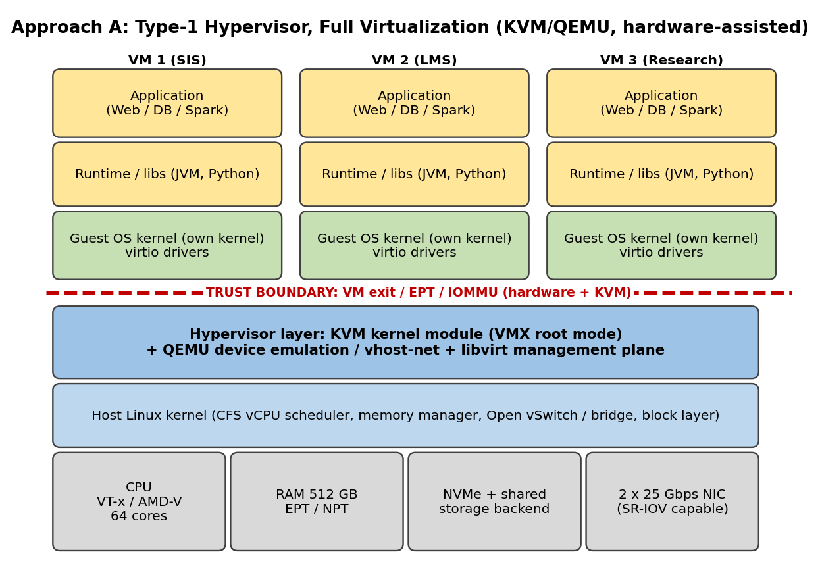
Figure 1: Layered architecture of Approach A (KVM/QEMU, hardware-assisted full virtualization)
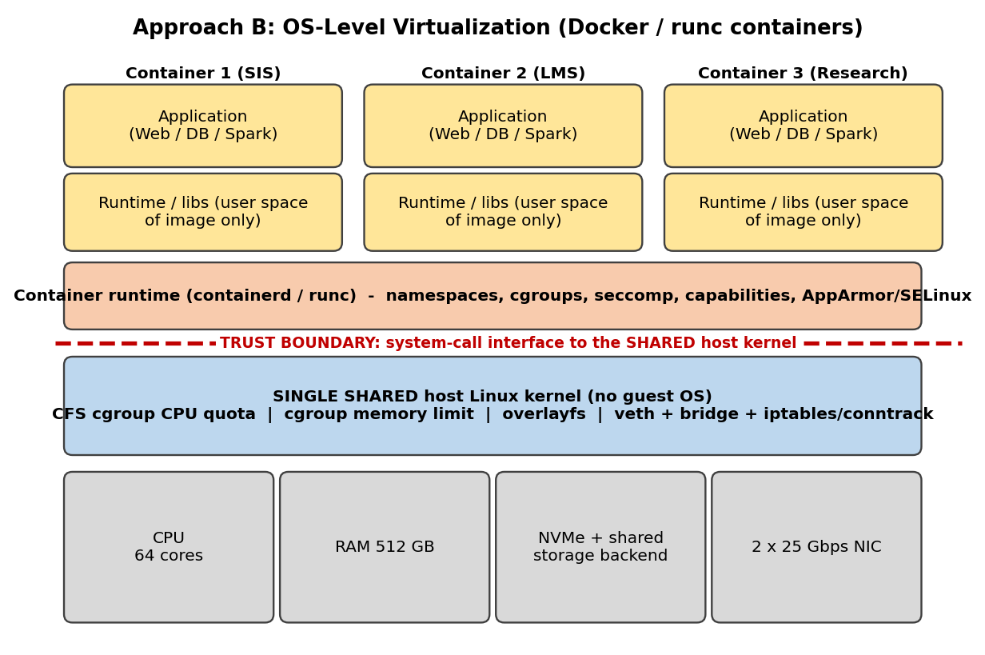
Figure 2: Layered architecture of Approach B (Docker/runc containers on a shared kernel)
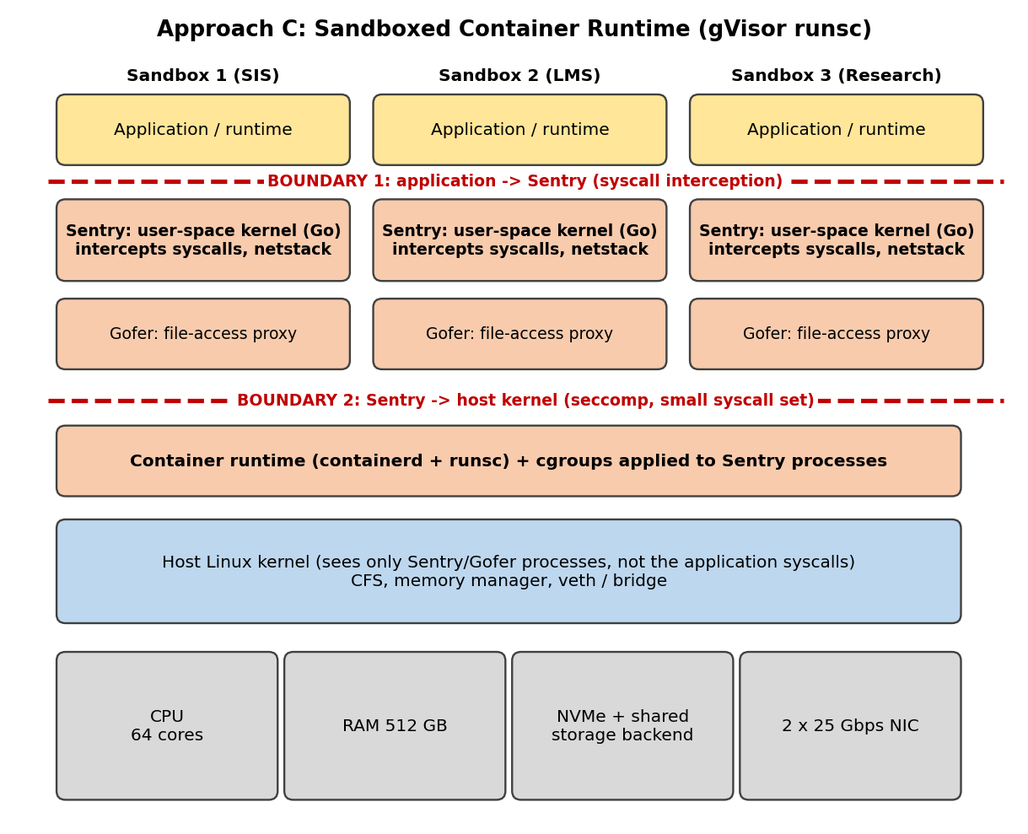
Figure 3: Layered architecture of Approach C (gVisor sandboxed container runtime)

Table 1: Isolation and resource virtualization per approach
Aspect | A: KVM VM (Type-1, full virt.) | B: Containers (runc) | C: gVisor sandbox
Isolation enforced by | CPU virtualization extensions (VMX root / non-root), EPT page tables and IOMMU, controlled by KVM. QEMU runs unprivileged (sVirt/SELinux) | The shared host kernel: namespaces, cgroups v2, seccomp-bpf, capabilities, AppArmor/SELinux | Sentry (user-space kernel in Go) plus a seccomp filter on the host; Gofer mediates file access
Trust boundary | Guest kernel ↔ hypervisor (VM-exit interface and emulated devices). Guest kernel is untrusted but confined to its VM | Container process ↔ host kernel through the full syscall interface. The whole kernel is in the trusted computing base | Two boundaries: application ↔ Sentry, then Sentry ↔ host kernel (small allowed syscall set)
CPU | Each vCPU is a QEMU thread run in VMX non-root mode; sensitive events cause a VM exit to KVM; threads scheduled by host CFS, so overcommit is possible | Containers are ordinary processes. cgroup cpu.max / cpu.weight limit them; no vCPU abstraction, no exits | App threads run under the Sentry; syscalls are trapped and re-implemented; host CFS schedules Sentry threads
Memory | Guest-physical to host-physical via two-dimensional EPT/NPT walk; ballooning, KSM and THP to overcommit | Native address translation; cgroup memory.max with OOM killer; page cache shared with host | Sentry manages application memory on top of host memory-mapped files; own virtual memory manager
Storage | virtio-blk / virtio-scsi to QEMU I/O thread or vhost-user; qcow2 or raw images on shared storage | overlayfs layers or volumes on host file system; io.max throttling | All file operations go through Gofer (RPC to host file system)
Network | virtio-net + vhost-net to tap, then Linux bridge or Open vSwitch; optional SR-IOV VF passthrough | Network namespace + veth pair to bridge, iptables NAT and conntrack (CNI) | User-space TCP/IP stack (netstack) or host-network passthrough, then veth/bridge
Why relevant to EduCloud | SIS/LMS hold regulated records; separate kernels let departments with outdated guests coexist; live migration enables host patching; mature tooling | Highest density and fastest start; fits trusted internal research and stateless micro-services | Container workflow with a much smaller host-kernel attack surface; candidate for untrusted code without a full guest OS

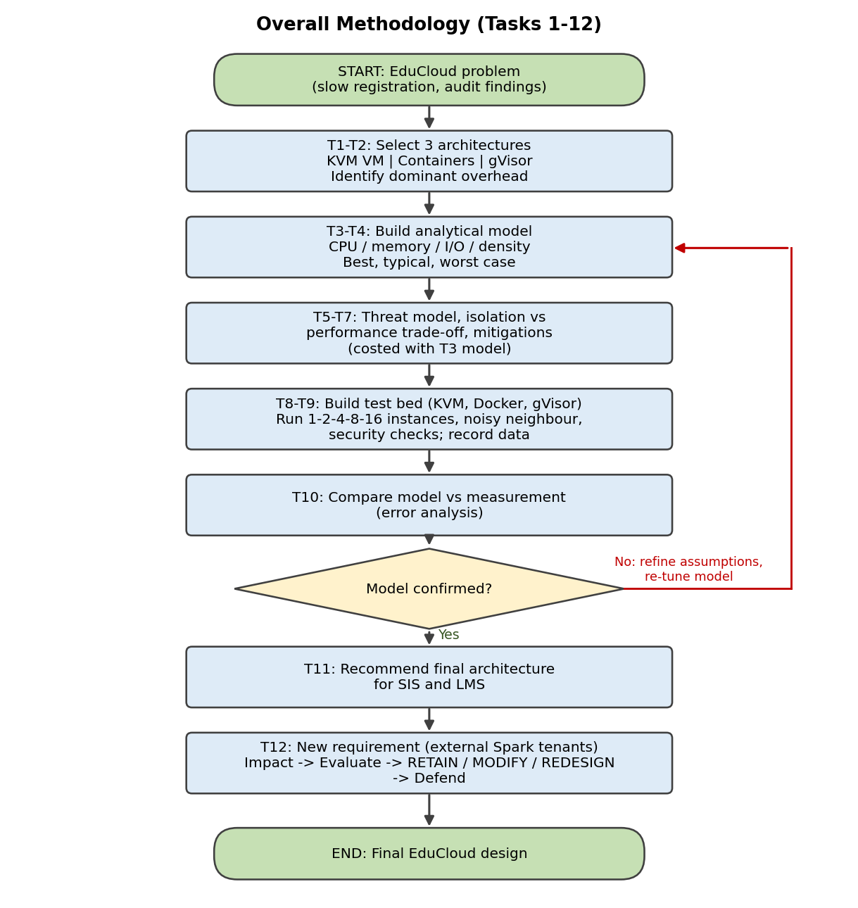
Figure 4: Overall methodology flowchart (Tasks 1–12)

TASK 2: Identify the Dominant Overhead Source

A: KVM VM – VM exits on the virtual-I/O path
- What: each VM exit is a hardware transition from guest (VMX non-root) to KVM (root) and back, costing E = 1.5 µs. The frequent causes are virtio queue notifications (kicks), interrupt injection and end-of-interrupt, IPIs and HLT. Two-dimensional EPT page walks are a smaller secondary cost (1–3%).
- Where: at the guest/hypervisor boundary (Figure 1, trust boundary). If the device is not handled in vhost, the exit continues to QEMU in user space, which is slower still.
- Why it is the right focus: CPU-bound guest code runs almost natively, but registration week is network- and disk-heavy web/database traffic, so the exit rate is set by the I/O rate. EPT cost depends on the TLB-miss rate and is bounded by huge pages.
- How it scales: exit rate per vCPU r = r0 + x·λ_v, so the lost CPU fraction o = r·E grows linearly with I/O: 3.3% at λ_v = 10,000/s and 30.3% at 100,000/s. With more co-located VMs the per-exit cost E itself rises (cache/TLB pollution, vhost and softirq threads competing for the same cores, more timer/HLT wake-ups when overcommitted). The model keeps E fixed, so it is a lower bound.

B: Containers – virtual switch (veth + bridge + netfilter) processing
- What: every packet crosses the container network namespace, a veth pair, the host bridge and iptables/conntrack. This adds about 0.3 µs per packet (A6) on top of the native path.
- Where: host kernel softirq context, on the same cores that run the application. There are no VM exits and no syscall interception, and CPU and memory access are native, so nothing else in the architecture adds comparable cost.
- Why it is the right focus: the SIS/LMS traffic is web request/response over many small packets, which is exactly the path that is traversed twice (container and host stack). CFS quota throttling is a secondary effect that mainly hurts tail latency.
- How it scales: per-packet cost c_p(n) = c_p0(1 + ε·log2 n), because conntrack hash chains grow with the number of flows (proportional to n) and bridge forwarding tables and cache footprints grow. The overhead is paid per packet, so it grows with packet rate, not with CPU load.

C: gVisor – system-call interception
- What: every application syscall is trapped and executed by the Sentry (S_g = 2.0 µs instead of 0.2 µs native). File operations additionally become Gofer RPCs.
- Where: at the application ↔ Sentry boundary (Figure 3, boundary 1).
- Why it is the right focus: web servers and databases issue tens of thousands of read/write/epoll/futex calls per second per core, so the syscall rate σ directly sets the overhead: o = σ(S_g − S_native).
- How it scales: the per-call cost is constant but σ rises with the I/O rate (40,000/s typical gives 7.2%, 100,000/s gives 18%). With more sandboxes, Sentry thread counts, Go garbage collection and host context switches add jitter. The user-space network stack also makes throughput CPU-bound instead of line-rate-bound (Task 3).

TASK 3: Quantitative Performance Model
Notation: P = 64 physical cores per host, v = 4 vCPU per instance, R = vCPU:pCPU overcommit ratio, u = average vCPU utilisation, M = 512 GB, m = 8 GB. All assumptions are in Table 0.

3.1 CPU model (overcommit, steal and virtualization overhead)
When all vCPUs are busy, each vCPU gets 1/R of a core. When utilisation is u, demand per physical core is R·u, so a vCPU receives its full demand while R·u ≤ 1 and a 1/(R·u) share beyond that. The fraction it does not get is steal time:
f(R,u) = min(1, 1/(R·u)) steal s = 1 − f(R,u)
Overhead fractions follow from Task 2 (exits for A, packet path for B, syscalls for C):
o_A = (r0 + x·λ_v)·E + o_EPT o_B = o_cg + o_nf o_C = o_cg + σ·(S_g − S_n)
Effective per-instance CPU capacity (in physical-core equivalents), degradation and physical-core load are:
C_inst = v · f(R,u) · (1 − o) D = 1 − f(R,u)·(1 − o) ρ = R·u / (1 − o)
A request needing W seconds of CPU work takes W / (f·(1 − o)) wall-clock seconds, so the latency dilation is L = 1/(f(1 − o)). If ρ > 1 the run queue is unstable and requests time out.
Worked example (KVM, typical overhead o = 5.3%, R = 2, u = 0.9): f = 1/(2×0.9) = 0.556, steal = 44.4%, C_inst = 4 × 0.556 × 0.947 = 2.10 cores, D = 47.4%.

Table 3.1: Effective CPU per instance (cores out of 4) with typical overhead
Case | R = 1:1 | R = 2:1 | R = 4:1 | R = 8:1
Steal time, u = 0.6 | 0% | 16.7% | 58.3% | 79.2%
A: KVM, u = 0.6 | 3.79 | 3.16 | 1.58 | 0.79
B: Container, u = 0.6 | 3.92 | 3.27 | 1.63 | 0.82
C: gVisor, u = 0.6 | 3.67 | 3.06 | 1.53 | 0.77
Steal time, u = 0.9 | 0% | 44.4% | 72.2% | 86.1%
A: KVM, u = 0.9 | 3.79 | 2.10 | 1.05 | 0.53
B: Container, u = 0.9 | 3.92 | 2.18 | 1.09 | 0.54
C: gVisor, u = 0.9 | 3.67 | 2.04 | 1.02 | 0.51

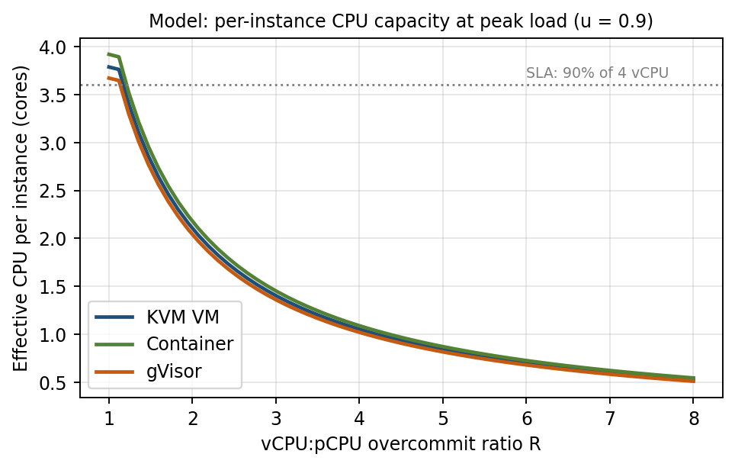
Figure 5: Model prediction of per-instance CPU capacity versus overcommit ratio (u = 0.9)

3.2 Memory model
The number of instances that fit without ballooning, swapping or page sharing is limited by committed memory:
N_mem = floor( (M − M_h) / (m + m_o) )
This gives 59 (KVM), 62 (containers) and 61 (gVisor) instances per host (for KVM: (512 − 16)/(8 + 0.3) = 59.8). If the average working set is w = 5 GB, ballooning and page sharing allow N_bal = floor((M − M_h)/(m_o + w)) = 93 / 99 / 98, but the risk of swapping rises when many working sets peak together. Today EduCloud commits 25 × 8.3 = 207 GB (40%), so memory is not the cause of the slow registration week; CPU and I/O are.

3.3 I/O and network model
Per-packet CPU cost grows slightly with the number n of instances sharing the device, and total throughput is the smaller of the wire limit and the CPU limit of the k packet-processing cores:
c_p(n) = c_p0 · (1 + ε·log2 n) T_tot(n) = min( η·L , k·S_pkt / c_p(n) ) T_inst(n) = T_tot(n) / n
with L = 25 Gbps, η = 0.94, S_pkt = 12,000 bits, k = 4, so the wire limit is 23.5 Gbps. Per-packet costs: c_p0(A) = 1.0 + (2 × 1.5)/16 + 0.15 = 1.34 µs; c_p0(B) = 1.30 µs; c_p0(C) = 3.5 µs. One core therefore moves 12/c_p Gbps: 8.96 (A), 9.23 (B) and 3.43 (C). For KVM at line rate the packet path uses 23.5 × 1.34/12 = 2.6 cores (4% of the host).

Table 3.2: Network throughput per instance (Gbps) when n instances share one 25 Gbps NIC
N | 1 | 2 | 4 | 8 | 16
A: KVM (vhost-net) | 23.50 | 11.75 | 5.88 | 2.94 | 1.47
B: Container (veth) | 23.50 | 11.75 | 5.88 | 2.94 | 1.47
C: gVisor (netstack) | 13.71 | 6.66 | 3.23 | 1.57 | 0.77

A and B are wire-limited, so they are equal in network throughput but differ in the CPU they leave for applications. C is CPU-limited at about 12–14 Gbps in total and falls to 0.77 Gbps per instance at n = 16, below the 0.5 Gbps target for n > 24.
Disk: the same structure applies: I_tot = min(I_dev, k_io / c_io), I_inst = I_tot/n. With c_io = 8.5 / 5.3 / 20 µs this gives I_tot = 235,000 (A), 377,000 (B) and 100,000 (C) IOPS, i.e. 14,700 / 23,600 / 6,250 IOPS per instance at n = 16.
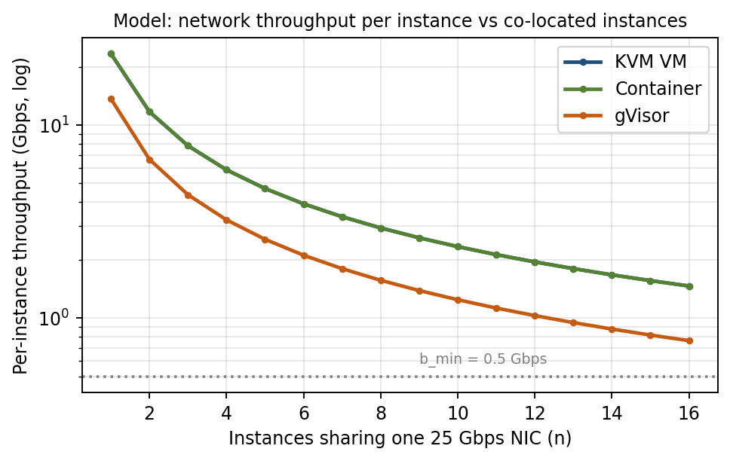
Figure 6: Model prediction of network throughput per instance versus number of instances

3.4 Density under the service-level target
For degradation D ≤ 10% we need f(1 − o) ≥ 0.9, which gives the maximum overcommit ratio. The other three limits come from memory, network and disk:
R_max = (1 − o) / (0.9·u) N_cpu = floor(R_max·P / v)
N_net = max{ n : T_tot(n)/n ≥ 0.5 Gbps } N_io = floor( I_tot / 5000 ) N = min(N_cpu, N_mem, N_net, N_io)

Table 3.3: Instances per host that meet the ≤10% target (4 vCPU / 8 GB each)
Approach | R_max (u=0.6) | N_cpu | N_mem | N_net | N_io | N (u=0.6) | N (u=0.9)
A: KVM | 1.75 | 28 | 59 | 47 | 47 | 28 | 18
B: Container | 1.82 | 29 | 62 | 47 | 75 | 29 | 19
C: gVisor | 1.70 | 27 | 61 | 24 | 20 | 20 | 18

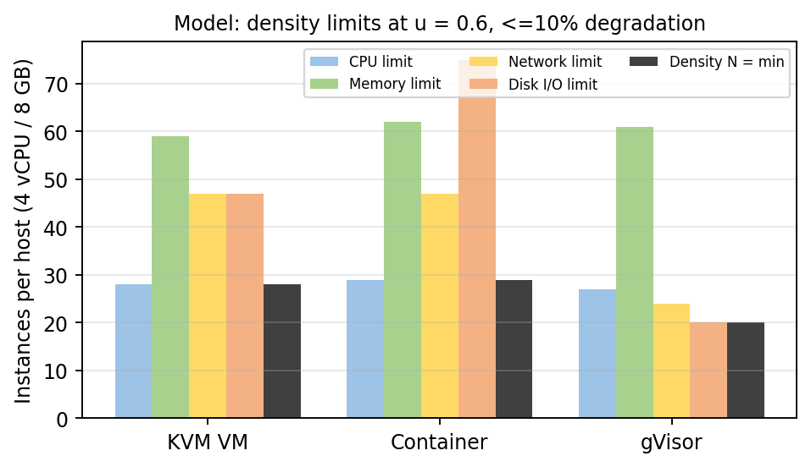
Figure 7: Density limits per host at u = 0.6
At u = 0.9, R_max is 1.17 (KVM), 1.21 (containers), 1.13 (gVisor), so CPU is the binding limit for all three and gVisor is additionally close to its I/O limit (20 vs 18).

3.5 Validation against the observed EduCloud problem
Today R = 25 × 4/64 = 1.56. At u = 0.9 the model gives f = 0.711 (steal 28.9%), C_inst = 2.69 of 4 cores, latency dilation L = 1.48 and ρ = 1.48 > 1. The run queue is unstable, so requests time out and logins fail, which matches the report. At u = 0.6, ρ = 0.99 is borderline (responses slow), and at u = 0.3 (ρ = 0.49) everything is fine. Under the SLA, a host can carry only 18 such VMs at the 3× peak, so 400 VMs would need 23 hosts if all were equally busy. Only 16 exist, which is why workloads must be separated by priority (Task 11).

TASK 4: Performance Under Different Operating Conditions
Model inputs per condition come from Table 0 (A3–A5). CPU-bound latency dilation is L = 1/(f(1 − o)); it excludes queueing and therefore understates tail latency when ρ approaches 1.

Table 4.1: Overhead fraction o and CPU latency dilation L
Condition | A: KVM o / L | B: Container o / L | C: gVisor o / L
Best (R = 1.1, u = 0.3, CPU-bound) | 1.3% / 1.01× | 0.5% / 1.01× | 1.4% / 1.01×
Typical (R = 1.1, u = 0.9, mixed web + DB) | 5.3% / 1.06× | 2.0% / 1.02× | 8.2% / 1.09×
Worst (I/O storm, current R = 1.56, u = 0.9) | 33.3% / 2.11× | 5.0% / 1.48× | 19.0% / 1.74×

Best case
Workload and placement: CPU-bound, low I/O, R ≤ 1 so no steal, large pages, vCPUs pinned, I/O device passthrough or batched notifications.
- KVM: the guest runs in VMX non-root mode and almost never exits (r ≈ r0 = 2,000/s, 0.3%). Only EPT walks (1%) remain, so latency and throughput are within about 1% of native.
- Containers: no virtualization layer at all; only cgroup accounting (0.5%).
- gVisor: few syscalls (2,000/s), so interception costs 0.36% plus 1% base. Even here the Sentry adds fixed latency per call, but with few calls it is invisible.

Typical case: registration-week mixed web and database load
- KVM: about 22,000 exits/s per vCPU (virtio kicks and completion interrupts). Each costs 1.5 µs, so 3.3% of every vCPU is spent in KVM, plus 2% EPT = 5.3%. With R ≤ 1.1 there is no steal, so latency is +5.6% and throughput −5%. Both are inside the 10% target; the SIS pool must therefore keep R ≤ 1.1.
- Containers: packets traverse veth/bridge/conntrack (about 0.3 µs each). With the application sharing the same cores, o = 2%, the lowest of the three, so latency +2%.
- gVisor: 40,000 syscalls/s × 1.8 µs extra = 7.2% (8.2% with base), and database fsync/pread paths go through Gofer RPCs. Latency +9% and DB-heavy request throughput drops about 8%, close to the SLA edge.
At the current R = 1.56 and u = 0.9 the effect is much worse than any of these overheads: steal of 29% and ρ = 1.48 dominate (Task 3.5).

Worst case

(a) I/O storm and noisy-neighbour interference
- KVM: a neighbour at λ_v = 100,000 events/s produces 202,000 exits/s per vCPU, so o = 30.3% + 3% = 33.3%. At R = 1.56 steal adds another 29%, giving L = 2.11 and throughput ≈ 47% of nominal. Inside the layer: vhost threads and softirqs of the noisy VM compete with victim vCPU threads in CFS; cache and TLB pollution makes each exit costlier than the nominal 1.5 µs. Shares, CPU pinning and I/O limits (Task 7) bound this.
- Containers: CPU is protected only by cgroup limits (o = 5%), but all tenants share one kernel: softirq time, conntrack table, page cache, dentry cache and the block queue are not isolated. A noisy neighbour can exhaust these, so tail latency rises sharply even though the average overhead is small (qualitative; to be measured in Task 8).
- gVisor: a syscall storm (100,000/s) gives o = 19% and saturates Sentry threads; Go garbage collection adds pauses. The noisy sandbox cannot hurt the host kernel directly but still consumes shared cores, so latency +74% at R = 1.56.

(b) Memory overcommit with swapping
Effective memory access time T_eff = (1 − p)·t_mem + p·t_swap, with t_mem = 100 ns and NVMe swap-in t_swap = 100 µs. At fault probability p = 0.1% this is 0.2 µs (2× slower); at p = 1% it is 1.10 µs (11× slower). Latency collapses non-linearly, so memory must not be overcommitted on the SIS pool (N_mem = 59 limit). Ballooning in KVM can avoid hard swapping but costs guest page-cache hits. Containers hit the cgroup OOM killer instead of swapping; gVisor behaves like containers.

(c) Live migration during peak load
Pre-copy time for an 8 GB SIS VM with migration bandwidth B = 10 Gbps = 1.25 GB/s and dirty rate D = 0.1 GB/s is T = M_vm/(B − D) = 8/1.15 ≈ 7 s. Dirty-page tracking causes write-protect exits at D/4 KiB = 26,200 per second, which at 1.5 µs is 3.9% of one core. The real damage is network: migration takes 10 of 25 Gbps (40%), which on a shared NIC cuts SIS bandwidth from 23.5 to about 14 Gbps total. Containers cannot be live-migrated (they must be checkpointed with a pause or restarted), and gVisor only supports checkpoint/restore, not live migration.

TASK 5: Security Threat and Vulnerability Analysis

5.1 Attack surface per approach
Surface | A: KVM VM | B: Containers | C: gVisor
Hypervisor / kernel interface | KVM kernel module and VM-exit handlers (narrow, hardware-defined) | Entire host kernel syscall interface (hundreds of calls, many drivers and file systems) | Sentry implements the syscalls in memory-safe Go; only a small subset of host syscalls is allowed by seccomp
Device emulation | QEMU emulated devices and virtio backends (large C code base; historically the main escape path) | None (no emulated devices); /proc, /sys and device nodes exposed to the container | Gofer and netstack, no emulated hardware
Shared kernel | No, each VM has its own guest kernel | Yes, one kernel for all tenants | Host kernel shared but reached only via Sentry
Management plane | libvirt / OpenStack API, QEMU monitor, hypervisor admin accounts | Docker daemon socket (root-equivalent), registry | Docker/containerd plus runsc
Images and snapshots | Large qcow2 images and snapshots hold memory and disk secrets; freely copied between teams (audit finding) | Layered images from registries; tampering or vulnerable layers | Same as containers
Virtual network | Linux bridge / OVS shared by VMs on a host | Default docker bridge puts containers on one L2 segment; CAP_NET_RAW enables spoofing | Same bridge, but raw sockets are handled by netstack

5.2 Threat matrix (six threat categories)
Exposure scale: 1 = low, 2 = medium, 3 = high. The scores are used again in Task 6.
Threat | A: KVM | B: Cont. | C: gVisor | Reason from architecture and trust boundaries
T1: Guest/container escape | 1 | 3 | 1 | A needs a bug in KVM or in a QEMU device; B needs only one kernel or runc flaw (shared kernel, full syscall surface); C needs a Sentry bug and then a host-kernel bug through a narrow seccomp filter
T2: Cross-tenant side channels (cache, SMT, L1TF/MDS/Spectre) | 2 | 3 | 2 | All share cores and caches. A can use SMT-off, core scheduling and L1D flush on VM entry; B shares the kernel and data structures as well; C gains little against hardware channels
T3: Hypervisor / kernel / runtime vulnerabilities | 2 | 3 | 1 | A: guest-kernel bugs stay inside one VM, but a hypervisor bug is catastrophic. B: every host-kernel CVE exposes all containers. C: smaller exposed host surface, but the Sentry must be patched too
T4: VM sprawl, unpatched guests, image tampering and copying | 3 | 2 | 2 | A carries a full guest OS per VM (audit: outdated kernels, free image copying). B and C rebuild small images, but unsigned or stale layers are still a risk
T5: Insecure live migration | 3 | 1 | 1 | A streams guest memory (including student-record caches) over the network; plaintext migration can be sniffed or altered. B and C cannot live-migrate, but checkpoint files also contain memory
T6: Virtual-network sniffing and spoofing | 2 | 3 | 2 | B shares an L2 segment by default and may hold raw-socket capability; A and C need explicit port security and VLANs but are not exposed by default
Weighted exposure E (weights 5,4,4,2,3,2) | 40 | 52 | 28 | Weights reflect impact on student-record confidentiality and integrity (escape 5, side channel 4, vulnerability 4, sprawl 2, migration 3, network 2)

5.3 Impact on confidentiality, integrity and availability of student records
- Confidentiality: an escape or side channel exposes other tenants’ records (B worst: one flaw reaches every container; A needs a hypervisor flaw). Unencrypted migration (A) leaks memory contents in transit.
- Integrity: a tampered or unsigned image (all approaches) or a kernel escape (B) lets an attacker alter grades or registration data.
- Availability: in B a shared-kernel panic or resource exhaustion takes down every container on the host, whereas in A a guest crash affects only one VM; a noisy neighbour (Task 4) is an availability attack in all approaches, most damaging for A’s exit storms.

TASK 6: Isolation–Performance Trade-off Formulation
The formulation uses the density limits from Task 3 (N_cpu, N_mem, N_net, N_io) and the exposure scores from Task 5 (Table 5.2).

Decision variables
- a_t ∈ {KVM, CONT, GVIS}: approach chosen for tenant class t ∈ {SIS, LMS, Research} (Task 12 adds Ext).
- x_{t,h} ≥ 0 (integer): number of instances of class t on host h; z_h ∈ {0,1}: host h is used.
- R_h ≥ 1: vCPU overcommit ratio on host h; s_h ∈ {0,1}: SMT enabled; d_t ∈ {0,1}: class t on dedicated hosts; m_j ∈ {0,1}: mitigation j applied (SMT-off, TLS migration, image signing, micro-segmentation, KPTI).

Objective
minimise J = w_H · Σ_h z_h + w_S · Σ_t I_t · E_t(a_t, d_t, m) + w_P · Σ_t max(0, D_t^storm − 0.10)
The first term is hardware cost (number of hosts). The second is residual security risk: impact I_t of class t times exposure E_t = Σ_k w_k·λ_k(a_t)·μ_k(d_t, m), where λ_k is the Table 5.2 score and μ_k ∈ (0,1] is the residual factor left by the mitigations (for example μ = 0.4 for SMT-off against side channels, 0.2 for TLS migration, 0.5 for image signing). The third term penalises degradation above 10% in the worst (storm) condition from Task 4.

Constraints
- C1 performance: D_t = 1 − f(R_h, u_t)(1 − o_{a_t}) ≤ 0.10 for t ∈ {SIS, LMS}, which is equivalent to R_h ≤ R_max(a_t, u_t) (Task 3.4).
- C2 CPU: Σ_t v·x_{t,h} ≤ R_h · φ(s_h) · P, with φ = 1 if SMT on and 0.8 if off.
- C3 memory: Σ_t (m + m_o(a_t))·x_{t,h} ≤ M − M_h(a).
- C4 network and disk: Σ_t b_t·x_{t,h} ≤ T_tot(a, n_h) and Σ_t i_t·x_{t,h} ≤ I_tot(a), with b = 0.5 Gbps and i = 5,000 IOPS per SIS instance.
- C5 isolation level: ι(a_SIS) ≥ ι_min where ι(CONT) = 1, ι(GVIS) = 2, ι(KVM) = 3 and ι_min = 3 for student records (hardware-enforced boundary).
- C6 co-location: y_{SIS,h} + y_{Ext,h} ≤ 1 (no external tenant on a host holding SIS); s_h = 0 on any host mixing trust domains unless core scheduling is enabled.
- C7 hosts: Σ_h z_h ≤ 16. C8 operations: SIS hosts must support live migration for patching. C9 compatibility: SIS database needs full Linux syscall compatibility.

How the pieces combine (illustration for the 100 SIS/LMS instances at u = 0.9)
Mitigated exposure E uses the factors above (TLS migration 0.2, SMT-off or core scheduling 0.4, KPTI/patching 0.7, signing 0.5, micro-segmentation 0.4). Core scheduling (8% capacity) and KPTI (1.2%) are applied to all three options when computing N. Weights: w_H = 1 per host, w_S·I = 0.25 per exposure unit, w_P = 10 per unit of excess storm degradation.
Option for SIS/LMS | Hosts (N at u=0.9) | Exposure E, raw → mitigated | Storm degradation D | J | Constraints C5, C8, C9
A: KVM + mitigations | 7 (N = 16) | 40 → 20.2 | 33% (10.8% after vhost/SR-IOV + QoS) | 7 + 5.05 + 0.08 = 12.1 | All satisfied
B: Containers | 6 (N = 17) | 52 → 33.2 | 5% | 6 + 8.3 + 0 = 14.3 | Fails C5 (ι = 1) and C8
C: gVisor | 7 (N = 16) | 28 → 15.2 | 19% | 7 + 3.8 + 0.9 = 11.7 | Fails C8 (no live migration) and C9 (syscall gaps)

Reading the result: the objective alone puts gVisor close to KVM, because its exposure is lowest and host counts are equal at this scale. The decisive part of the model is the constraint set: C5, C8 and C9 remove containers and gVisor for SIS, so KVM with mitigations is the minimum-J feasible option (J = 12.1). The weights are judgement-based; changing them only changes the ranking inside the feasible set.

TASK 7: Evaluate Mitigation Strategies
Seven mitigations are evaluated against the threats of Task 5 with costs derived from the Task 3 model (KVM, typical o = 5.3%, u = 0.6 unless stated).
Mitigation | Threat addressed and why it applies | Residual risk | Cost (Task 3 model) | Acceptable for SIS?
M1: Disable SMT (or Linux core scheduling) | T2: removes sibling-thread L1TF/MDS leakage between VMs on the same core | LLC and memory-bus channels remain; transient-execution variants on a single thread | SMT off: capacity φ = 0.8, so N_cpu 28 → 22 (u = 0.6) and 18 → 14 (u = 0.9); 100 SIS VMs need 8 hosts instead of 6. Core scheduling: about 8% loss, N = 17 at u = 0.9 | Core scheduling in Pool S (same trust domain); SMT off mandatory wherever trust domains mix (Pool X)
M2: Dedicated hosts for sensitive tenants | T1, T2, T3: no co-residence with other tenants | Shared storage and management plane | No extra hosts: SIS needs 100/16 → 7 hosts anyway; research 300/60 → 5 hosts (with ballooning/KSM). The cost is lost multiplexing: Pool S is only 33% busy at normal load | Yes (required by Task 12 regulation)
M3: KPTI plus patched guest and host kernels | T3: blocks Meltdown-class reads; patching removes known kernel CVEs | Zero-days; hypervisor bugs | Syscall 0.2 → 0.5 µs: 40,000/s × 0.3 µs = 1.2% overhead, N_cpu 28 → 27 | Yes (negligible)
M4: Image signing, golden images, scanning | T4: stops tampered images and uncontrolled copies; fixes sprawl and stale kernels | Signed but vulnerable images; insider with signing rights | No run-time cost; 1–2 s boot verification; copy-on-write backing images save storage | Yes
M5: Micro-segmentation (OVS port security, per-tenant VLAN/VRF, per-VM firewall) | T6: prevents ARP/MAC spoofing and east-west sniffing | Misconfigured rules; attacks inside one segment | +0.15 µs per packet: 23.5 Gbps = 1.96 Mpps × 0.15 µs = 0.29 core (0.46%). KVM with 4 cores still delivers 4 × 12/1.49 = 32 Gbps, above the 23.5 Gbps wire limit, so throughput is unchanged | Yes
M6: Encrypted live migration (TLS/IPsec on a dedicated network) | T5: protects guest memory in transit and authenticates endpoints | Compromised endpoint hosts | AES-NI about 1 core per 8 Gbps (assumption): 10 Gbps migration = 1.25 cores (2% of host); time stays about 7 s for an 8 GB VM | Yes
M7: Sandboxed runtime (Kata/gVisor) or hardware memory encryption (SEV/TDX) | T1, T3 for container workloads; encryption also against privileged host attackers | Hardware or Sentry bugs | Kata/KVM: o ≈ 5.3% instead of 2%, +0.15–0.3 GB per pod; gVisor 8.2%; memory encryption about 2–8% on memory-bound jobs and limits live migration (assumption) | Optional; used for external tenants (Task 12)

Combined effect for the SIS pool: M1 (core scheduling) + M3 + M5 + M6 reduce mitigated exposure of KVM from 40 to 20.2 (Task 6) while costing roughly 8% + 1.2% + 0.5% + 2% of CPU. Density at u = 0.9 falls from 18 to 16 instances per host (R_max ≈ 1.06 over 64 cores), so the SIS pool is sized at 7 hosts (7 × 16 = 112 slots for 100 VMs).

TASK 8: Implement and Test

8.1 Test bed and design
Item | Choice
Host | Linux workstation or laptop (Ubuntu 22.04/24.04), ≥ 8 cores, ≥ 32 GB RAM, NVMe SSD. Record CPU model, lscpu, kernel version and whether nested virtualization is used
Approaches | A: KVM/QEMU + libvirt; B: Docker (runc); C: Docker with --runtime=runsc (gVisor)
Instance spec (identical) | 4 vCPU / 8 GB RAM (reduce to 2 vCPU / 4 GB if hardware-limited), same Ubuntu 22.04 base image and workload packages in all three
Scale | N = 1, 2, 4, 8, 16 co-located instances (if the host has fewer resources, scale proportionally and state it; the host overcommit is R = 4N / host cores)
Workloads | CPU: sysbench cpu; memory: sysbench memory; disk: fio 4 KiB random read; network: iperf3
Interference | Noisy neighbour: stress-ng CPU + memory and an fio flood in instance 1 while instance 2 is measured
Security validation | Kernel sharing, namespaces and cgroups, SMT/KPTI mitigation status (Section 8.4)
Repetitions | 5 per data point; report mean ± SD and p95

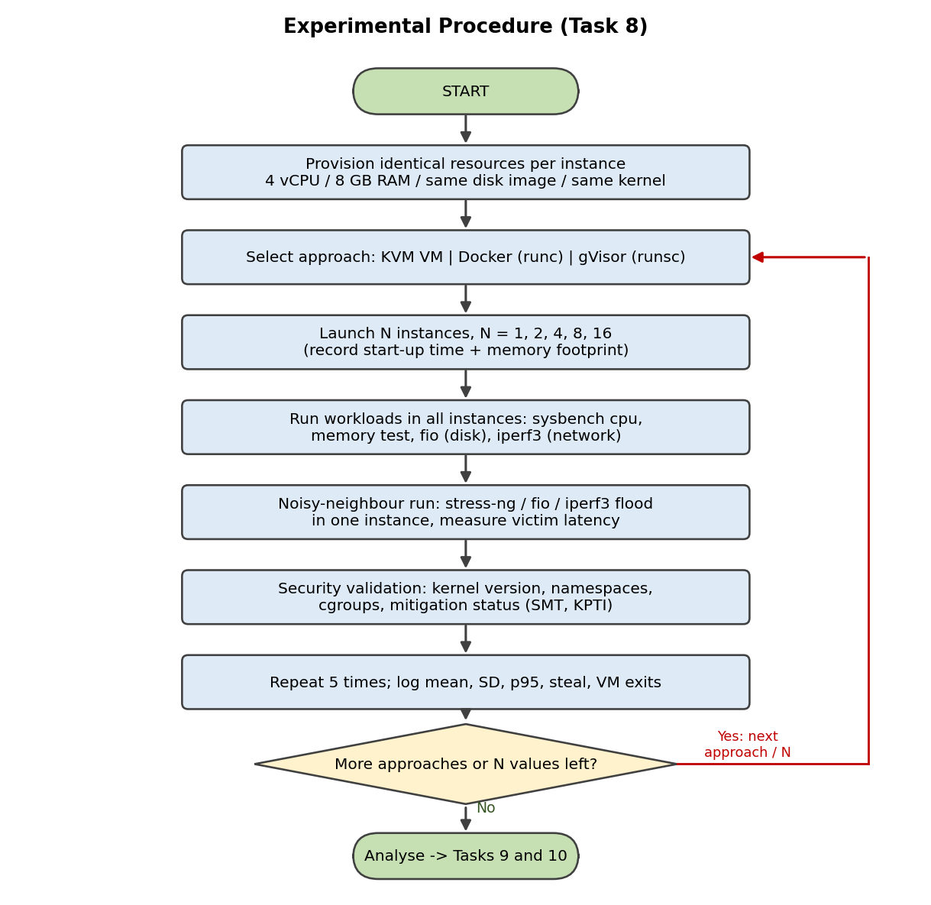
Figure 8: Flowchart of the experimental procedure

8.2 Installation
# host packages
sudo apt update && sudo apt install -y qemu-kvm libvirt-daemon-system virtinst cloud-image-utils \
docker.io sysbench fio iperf3 stress-ng sysstat linux-tools-generic jq
kvm-ok # confirm hardware virtualization (or nested virt)

# gVisor (runsc) and Docker registration
sudo apt install -y runsc # after adding the gVisor apt repo from gvisor.dev
sudo runsc install && sudo systemctl restart docker
docker run --rm --runtime=runsc hello-world

# benchmark container image (same packages as the VM image)
cat > Dockerfile <<EOF
FROM ubuntu:22.04
RUN apt-get update && apt-get install -y sysbench fio iperf3 stress-ng iputils-ping
EOF
docker build -t bench .

8.3 Launch scripts (identical resources)
# --- A: KVM VMs (qcow2 copy-on-write clones of one base image) ---
launch_kvm() { N=$1
for i in $(seq 1 $N); do
qemu-img create -f qcow2 -F qcow2 -b base.qcow2 vm$i.qcow2 20G
virt-install --name vm$i --vcpus 4 --memory 8192 --import \
--disk vm$i.qcow2,bus=virtio --network network=default,model=virtio \
--os-variant ubuntu22.04 --cloud-init user-data=user-data.yaml --noautoconsole
done; }

# --- B: containers ---
launch_cont() { N=$1
for i in $(seq 1 $N); do
docker run -d --name c$i --cpus 4 --memory 8g bench sleep infinity
done; }

# --- C: gVisor ---
launch_gv() { N=$1
for i in $(seq 1 $N); do
docker run -d --runtime=runsc --name g$i --cpus 4 --memory 8g bench sleep infinity
done; }

8.4 Workloads, metrics and security checks
# CPU and memory (run in every instance, 30 s, 4 threads)
sysbench cpu --threads=4 --time=30 --percentile=95 run
sysbench memory --threads=4 --memory-block-size=1M --memory-total-size=20G run

# Disk: 4 KiB random read, JSON output with latency percentiles
fio --name=rr --rw=randread --bs=4k --iodepth=32 --ioengine=libaio --direct=1 \
--size=1G --runtime=30 --time_based --group_reporting --output-format=json

# Network: server on the host, 4 parallel streams from each instance
iperf3 -s -D # host
iperf3 -c <host-ip> -t 30 -P 4 --json

# Noisy neighbour (instance 1) while instance 2 runs the workloads above
stress-ng --cpu 4 --vm 2 --vm-bytes 4G --timeout 60s &
fio --name=flood --rw=randwrite --bs=4k --iodepth=64 --direct=1 --size=2G --runtime=60 --time_based &

# Steal time, context switches, VM exits
mpstat -P ALL 1 30 # %steal inside guests
pidstat -w -p ALL 1 30 # context switches
sudo perf stat -e kvm:kvm_exit -a -- sleep 30 # VM exits on the host (A only)

# Start-up time and footprint
time (virsh start vm1 && until ssh vm1 true; do sleep 0.2; done)
time docker run --rm bench true
docker stats --no-stream ; free -m # memory per instance
Security validation (done for all three approaches):
uname -r # container shows HOST kernel; VM shows its own; gVisor shows emulated kernel
docker exec c1 ls -l /proc/self/ns # namespaces; compare with host: ls -l /proc/1/ns
docker exec c1 cat /sys/fs/cgroup/cpu.max /sys/fs/cgroup/memory.max
docker exec g1 dmesg | head # gVisor prints Sentry messages, not host kernel messages
grep . /sys/devices/system/cpu/vulnerabilities/* # mitigation status on host and in VM
lscpu | grep -i "thread(s) per core"
echo off | sudo tee /sys/devices/system/cpu/smt/control # SMT-off mitigation run
docker run --rm --pid=host bench ps aux | wc -l # shows lost PID isolation if misconfigured

8.5 Master script (identical order for every approach)
for APPROACH in kvm cont gv; do
for N in 1 2 4 8 16; do
launch_$APPROACH $N
for REP in 1 2 3 4 5; do
run_workloads_parallel $APPROACH $N $REP # sysbench, fio, iperf3 in all N, logs to results/
run_noisy_neighbour $APPROACH $N $REP
done
cleanup_$APPROACH
done
done
python3 summarise.py results/ > results.csv # mean, SD, p95 per metric
Correspondence with the model: the same 4 vCPU / 8 GB instances, the same workloads and R = 4N/host-cores let the Task 3 formulas be evaluated for the actual host (set P = host cores and use measured o). If nested virtualization is used for A, document it, because exit cost is then several times higher than the 1.5 µs assumed (Task 10).

TASK 9: Record Experimental Performance
The “model” column contains the Task 3/4 predictions. The “measured” cells must be filled from your own runs of the Task 8 scripts (5 repetitions each, mean ± SD). They are intentionally blank so that no fabricated measurement appears in the report.

9.1 Metrics and how each is computed
- Throughput: sysbench events/s (CPU), MiB/s (memory), fio IOPS and bandwidth, iperf3 Gbps. Latency: mean and 95th percentile from sysbench --percentile=95 and fio clat percentiles.
- CPU steal, context switches, VM exits: mpstat (%steal), pidstat -w, perf stat -e kvm:kvm_exit (A only).
- Start-up time and memory per instance: time to first successful command; docker stats or free -m before/after launch divided by N.
- Degradation vs bare metal: D = (X_bare − X_inst) / X_bare for throughput metrics and D = (L_inst − L_bare) / L_bare for latency, using the same benchmark run on the host with the same thread count.
- With and without mitigation: repeat the N = 1 and N = 16 runs with SMT off (/sys/devices/system/cpu/smt/control) and with pti=off versus pti=on.
- Variability: report mean ± SD over 5 repetitions; discard the first run as warm-up if it differs by more than 2 SD.

9.2 Results table (model prediction and measured values to be entered)
Metric | Model A / B / C | Measured A: KVM | Measured B: Cont. | Measured C: gVisor
sysbench CPU degradation vs bare metal, N = 1 (best case) | 1.3% / 0.5% / 1.4% | ____ ± ____ | ____ ± ____ | ____ ± ____
Per-instance CPU capacity at N = 16, R = 1 on a 64-core host (cores of 4) | 3.79 / 3.92 / 3.67 | ____ ± ____ | ____ ± ____ | ____ ± ____
Network per instance at N = 16 (Gbps, 25 Gbps NIC) | 1.47 / 1.47 / 0.77 | ____ ± ____ | ____ ± ____ | ____ ± ____
Disk IOPS per instance at N = 16 | 14,700 / 23,600 / 6,250 | ____ ± ____ | ____ ± ____ | ____ ± ____
p95 CPU latency dilation of victim under noisy neighbour (R = 1.56, u = 0.9) | 2.11× / 1.48× / 1.74× | ____ ± ____ | ____ ± ____ | ____ ± ____
VM exits per vCPU per second (typical load) | 22,000 / n.a. / n.a. | ____ ± ____ | n.a. | n.a.
Steal time, N = 16 (%) | 0–29% depending on R | ____ | ____ | ____
Memory footprint per idle instance | ≈ 0.3 GB + guest / 0.05 GB / 0.10 GB | ____ ± ____ | ____ ± ____ | ____ ± ____
Start-up time (expected order of magnitude) | 10–40 s / 0.3–1 s / 0.5–2 s | ____ ± ____ | ____ ± ____ | ____ ± ____
Density change with SMT off (N at u = 0.6) | 28 → 22 / 29 → 23 / 20 → 20 (I/O-bound) | ____ ± ____ | ____ ± ____ | ____ ± ____
KPTI overhead (σ = 40,000 syscalls/s × 0.3 µs) | 1.2% / 1.2% / 1.2% | ____ ± ____ | ____ ± ____ | ____ ± ____

9.3 Graphs
Graph 1: per-instance network throughput versus number of instances N (log y-axis), with error bars; overlay the model curve of Figure 6. Graph 2: victim p95 latency versus N with and without the noisy neighbour, overlaid on the CPU model of Figure 5 (L = 1/(f(1 − o))). The script below produces both from results.csv (columns: approach, N, metric, mean, sd).
import pandas as pd, matplotlib.pyplot as plt
df = pd.read_csv("results.csv")
def plot(metric, ylabel, fname, logy=False):
fig, ax = plt.subplots(figsize=(6.4, 3.6))
for a, g in df[df.metric == metric].groupby("approach"):
g = g.sort_values("N")
ax.errorbar(g.N, g["mean"], yerr=g.sd, marker="o", capsize=3, label=a)
ax.set_xlabel("Co-located instances N"); ax.set_ylabel(ylabel); ax.legend(); ax.grid(alpha=.3)
if logy: ax.set_yscale("log")
fig.savefig(fname, dpi=170, bbox_inches="tight")
plot("iperf_gbps_per_inst", "Gbps per instance", "graph1_net.png", logy=True)
plot("victim_p95_ms", "Victim p95 latency (ms)", "graph2_latency.png")
The predicted curves for both graphs are already given in Figures 5 and 6. The model predicts: network per instance falls as 1/N and is lowest for gVisor; victim latency under interference rises with R, most for KVM exit storms.

TASK 10: Compare Theory with Experiment
This section gives the comparison method, the predictions to be tested, and the reasoning for interpreting each possible deviation. Insert your measured values into Table 9.2 first.

10.1 Error analysis method
ε = (X_model − X_measured) / X_measured accept the model if |ε| ≤ 15%
Scaling efficiency S(N) = aggregate throughput(N) / ( N · throughput(1) )
- Compare trends first (monotonic decrease with N, slope on a log–log plot, ordering of approaches), then absolute values.
- For |ε| > 15%, locate the cause with the evidence in the table below before adjusting any model parameter, and refit only the parameter that the evidence supports (E, S_g, or c_p).

10.2 Predictions and plausible causes of deviation
Result to check | Model predicts | If measured value differs, likely cause
CPU overhead at N = 1 | A 1.3%, B 0.5%, C 1.4% | A higher than predicted: nested virtualization on a laptop (each exit costs several times more than 1.5 µs, so o scales with exit cost). C higher: runsc platform is ptrace or non-systrap, making S_g much larger than 2 µs
CPU per instance versus N (R > 1) | Falls as 1/R, nearly the same for A, B, C | Better than 1/R: instances are not all busy, so idle gaps are reused. Worse: scheduler latency, SMT siblings on a laptop (logical cores give only about 25% extra throughput), thermal throttling
Network per instance | A and B wire-limited and equal; C about half; all fall as 1/N | On a laptop, traffic over a bridge is CPU-bound, not NIC-bound: use T = k·12/c_p with measured c_p; the order B ≥ A ≫ C should remain. Loopback and veth shortcuts can inflate B
Disk IOPS | B > A ≫ C | Page cache hides the cost unless direct=1; qcow2 copy-on-write and host cache mode (A) are not modelled; NVMe thermal throttling
Memory bandwidth | Model has no bandwidth term, so it predicts ≈ native | Expect a larger drop at N = 16 for all approaches because the memory controller is shared; this is an unmodelled path
Noisy neighbour p95 | A 2.11×, B 1.48×, C 1.74× (CPU only) | B is likely worse than predicted because softirq, conntrack and page cache are shared kernel resources, which narrows or reverses the model’s advantage for B; A is likely close to or below prediction when shares and pinning are used
Start-up and footprint (not modelled) | VM ≫ gVisor > container | Pure measurement; consistent with the m_o values of Table 0 if within 2×

10.3 Which approach scales better
The model predicts that CPU per instance degrades identically for all three (1/R); scalability differs through overhead and I/O. At N = 16 the aggregate network throughput stays at the wire limit (23.5 Gbps) for A and B but falls from 13.7 to 12.2 Gbps for C (−11%), and the per-instance I/O limit N_io is 47 (A), 75 (B) and 20 (C). The expected ranking is therefore B ≳ A ≫ C, with the A–B gap about 3% in density (28 vs 29 at u = 0.6). If measurements show the A–B gap above about 10% at N = 16, the likeliest reason is exit-rate growth in A (cache/TLB pollution, which the model ignores); the fix is vhost/SR-IOV, not a change of approach.

10.4 Do the measurements change the security conclusions?
Observation | Effect on Task 5 conclusion
uname -r in container equals the host kernel; VM and gVisor differ | Confirms the shared-kernel exposure (T1, T3 = 3 for B) and the separate kernels of A and C
/sys/devices/system/cpu/vulnerabilities/* shows SMT or microcode mitigations missing on the host | Raises T2 for all approaches and makes M1 (SMT off or core scheduling) mandatory
Measured SMT-off cost much greater than 20% | Prefer core scheduling in Pool S; keep SMT off only in Pool X
gVisor or Kata overhead above 10% at typical load | Does not change isolation ranking but confirms they are unsuitable for SIS (Task 6, C1)
Container shows PID or network visibility to other containers when misconfigured | Reinforces T6 for B and the need for micro-segmentation (M5)

TASK 11: Recommend and Defend the Final Architecture

11.1 Recommendation
Use KVM virtual machines (Approach A) as the isolation unit for SIS, LMS and the examination portal, with containers inside the VMs for application packaging. Concretely:
- Pool S: KVM with virtio/vhost-net, vCPUs reserved or pinned, CPU overcommit ≤ 1:1 to 1.1:1 on SIS hosts (about 16 VMs per host), no memory overcommit, core scheduling and KPTI on, signed golden images, TLS-encrypted live migration on a separate NIC/VLAN.
- Internal research workloads stay in separate hosts (Pool R) with low CPU weight; they can use plain containers or VMs at up to 3.75:1 overcommit because their utilisation is about 0.2.
- gVisor is kept only as a fallback for untrusted, low-I/O utility jobs; plain containers on shared hosts are not used for student records.
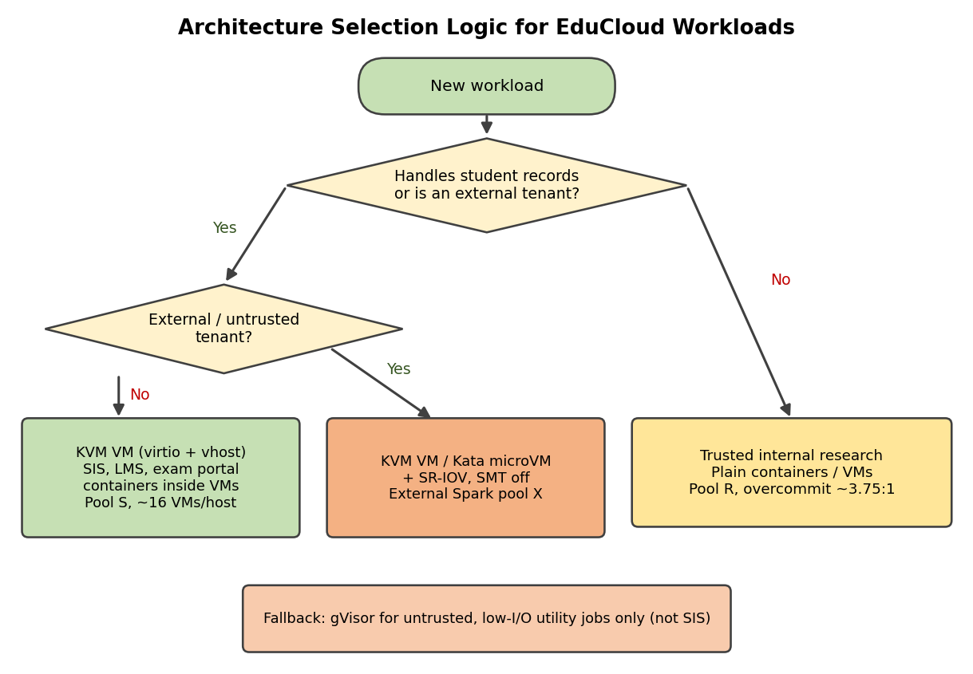
Figure 9: Selection logic that maps each workload to an architecture

11.2 Why this beats the alternatives
Criterion (weight) | A: KVM VM | B: Containers | C: gVisor
Performance, from Tasks 3–4 (0.30) | 4: o = 5.3% typical, N = 28 (u = 0.6); storm 33% unless mitigated | 5: o = 2%, N = 29; storm 5% | 2: o = 8.2%, N = 20; I/O limit 20 close to the target of 18
Isolation, from Task 5 (0.30) | 5: hardware boundary, exposure E = 40 → 20.2 mitigated | 2: shared kernel, E = 52 → 33.2 | 4: two software boundaries, E = 28 → 15.2
Operability (0.20) | 4: live migration, mature tooling, but a guest OS per VM to patch | 4: simple images, but host-kernel patch needs drain/reboot, no live migration | 2: no live migration, syscall gaps, thin tooling
Density and cost (0.20) | 3: 28 per host | 5: 29 per host | 3: 20 per host
Weighted score | 4.1 | 3.9 | 2.8

The scores are judgements derived from the model results above. Sensitivity: with performance and isolation weights summing to 0.6, containers overtake KVM only if the isolation weight falls below 0.25 (our weight is 0.30). For student records isolation is a hard constraint (Task 6, C5), so the weighted score only confirms the choice. The cost of choosing KVM over containers is about 3.4% density ((29 − 28)/29).

11.3 Modelled and observed performance
- Model: typical overhead 5.3%, latency dilation 1.06× at R ≤ 1.1, against 1.48× in today’s R = 1.56 configuration, so a 28% reduction in CPU-bound response time at the registration peak and ρ drops from 1.48 to about 0.95.
- Network and disk at 16 VMs per host: 1.47 Gbps and 14,700 IOPS per VM, above the 0.5 Gbps and 5,000 IOPS targets.
- Experiment: accept the choice if Task 9 shows measured o ≤ 10% for A at typical load and N = 16, and noisy-neighbour p95 within the model’s 2.11× bound (or lower with shares and pinning).

11.4 Security posture and residual risk
- Mitigated exposure falls from 40 to 20.2 (Task 6). Remaining risks: hypervisor/QEMU zero-days, LLC and memory-bus side channels, compromised management plane or signing keys, insiders. Controls: minimal QEMU device set, sVirt, prompt hypervisor patching, MFA and RBAC on the management plane, audit logging.

11.5 Operational costs
- Patching: guest kernels are the audit’s weak point, so rebuild signed golden images monthly (Packer) and replace VMs by rolling redeploy; host patches by live migration. Evacuating one host with 16 VMs of 8 GB at 10 Gbps takes about 16 × 7 s / 2 parallel ≈ 1 minute plus reboot; patch outside registration weeks (u = 0.3, R_max ≈ 3.5), when one host fewer is still within the target.
- Image management: copy-on-write backing images, signed registry, copy restricted by RBAC (closes the free-copying finding).
- Migration: TLS on a dedicated VLAN capped at 10 Gbps, costing about 1.25 cores (2%).
- Monitoring: steal %, exit rate, per-VM IOPS and Gbps, mitigation status, image age; alert when ρ > 0.8 on Pool S.

11.6 Limitations and trade-offs
- Lower density than containers by about 3.4% and a 10–40 s start-up, so elastic bursts are slower; exit storms can reach 33% unless vhost, SR-IOV or I/O limits are used.
- The model assumes homogeneous utilisation, constant exit cost and ideal fair sharing; the exit cost grows under contention, so predicted densities are optimistic by a few percent.
- Dedicated pools reduce statistical multiplexing: Pool S averages about 33% utilisation at normal load.

11.7 Practicality from 400 to several thousand instances
Host count follows H = Σ_classes ceil(N_class / N_density). For 3,000 instances split into 25% SIS-type (16 per host), 65% research (60 per host) and 10% external Spark (8 per host): 47 + 33 + 38 = 118 hosts. This is practical if (i) the control plane is cell-based (for example OpenStack cells of 20–30 hosts), (ii) the network is leaf-spine with 25 Gbps host links and a separate migration/storage VLAN, (iii) storage is a scale-out backend (Ceph or similar) with per-pool QoS, and (iv) patching and image builds are automated, because per-VM patch work grows as O(N). Running several services as containers inside each VM reduces the number of guest operating systems to patch.

TASK 12: Re-evaluate and Adapt the Design (Day-4 Challenge)

A. Impact Analysis
Original assumption | New reality | Consequence
All tenants trusted (university departments) | External collaborators run arbitrary code | Threat model changes from mistakes and insiders to hostile guests: escape attempts, cache-timing channels, abuse of device emulation and network
Short transactional web/DB load | Spark/Hadoop jobs run for hours, I/O- and network-bound | Greedy bulk flows and deep disk queues dominate shared NICs and storage; SIS latency is hurt for hours, not seconds
Peak about 1–2× normal | Registration peak 3× normal (u from 0.3 to 0.9) | R_max for the SLA falls to 1.17; at today’s R = 1.56 it is already over capacity (ρ = 1.48)
Maintenance by occasional migration of small VMs | Live migration of running VMs including 32 GB Spark VMs | Spark VM with 0.5 GB/s dirty rate: T = 32/(1.25 − 0.5) = 43 s, 40% of NIC used, and 131,000 write-protect exits per second (19.7% of a core)
Isolation is good practice | Regulation requires demonstrable isolation of student records from external tenants | Shared hosts cannot be proven isolated; separation must be structural and auditable

Performance and threat interaction: batch jobs and SIS compete for the same cores, NIC, storage queue and cache. Bulk flows win a flow-count-based share of the NIC; deep Spark queues win a queue-depth-based share of the device. The same shared resources become side channels and denial-of-service paths for an external attacker, so a performance problem is now also a security problem.

B. Evaluation of the Original Design
Scenario on one original host at the 3× peak (u = 0.9): 17 SIS VMs (68 vCPU) plus 4 Spark VMs (8 vCPU, 32 GB each). Spark traffic uses 64 flows per VM and queue depth 64; SIS uses 4 flows and queue depth 8 per VM.
Check | Model result | Target | Verdict
CPU: R = 100/64 = 1.56, f = 0.711, steal 28.9% | SIS latency dilation L = 1.48 | ≤ 1.11 | Fail
Network (flow-count share): SIS share = 68/(68 + 256) = 21% of 23.5 Gbps | 4.9 Gbps total, 0.29 Gbps per SIS VM | ≥ 0.5 Gbps | Fail
Disk (queue-depth share): 136/(136 + 256) = 35% of 235,000 IOPS | 4,800 IOPS per SIS VM | ≥ 5,000 | Marginal fail
Spark VM overhead under virtio (λ_v = 30,000/s): (2,000 + 60,000) × 1.5 µs + 3% | 12.3% | ≤ 10% (soft) | Fail
Isolation of student records from external tenants | Shared host, hypervisor, SMT siblings, NIC, storage queue | Demonstrable | Fail

If per-VM fair queuing were applied, SIS would get 23.5/21 = 1.12 Gbps per VM (pass), but each Spark VM would be capped at 1.12 Gbps instead of the roughly 5 Gbps it wants, so shuffle phases slow about five times. Performance and isolation cannot both be met on shared hosts. Other architectures for the external workload:
Option for external Spark | Overhead o | Network ceiling | Isolation from SIS | Live migration | Verdict
A: KVM + virtio on shared hosts (original) | 12.3% | 23.5 Gbps but 2.6 cores of host CPU | Weak (shared host) | Yes | Rejected
B: Containers on shared hosts | 2–5% | 23.5 Gbps | Poor (untrusted code on a shared kernel) | No | Rejected
C: gVisor | 19% | 12–14 Gbps (CPU-bound netstack) | Good boundary, but shared host | No | Rejected: shuffle needs line rate
D: KVM or Kata microVM + SR-IOV on dedicated hosts | ≈ 5.2% (exits 2,000 + 0.2 × 30,000 = 8,000/s → 1.2%, EPT 3%, IOMMU 1%) | 23.5 Gbps with almost no host CPU on the data path | Strong (separate hosts, no shared SMT or NIC) | No (drain and patch) | Chosen

C. Adaptation: MODIFY the design
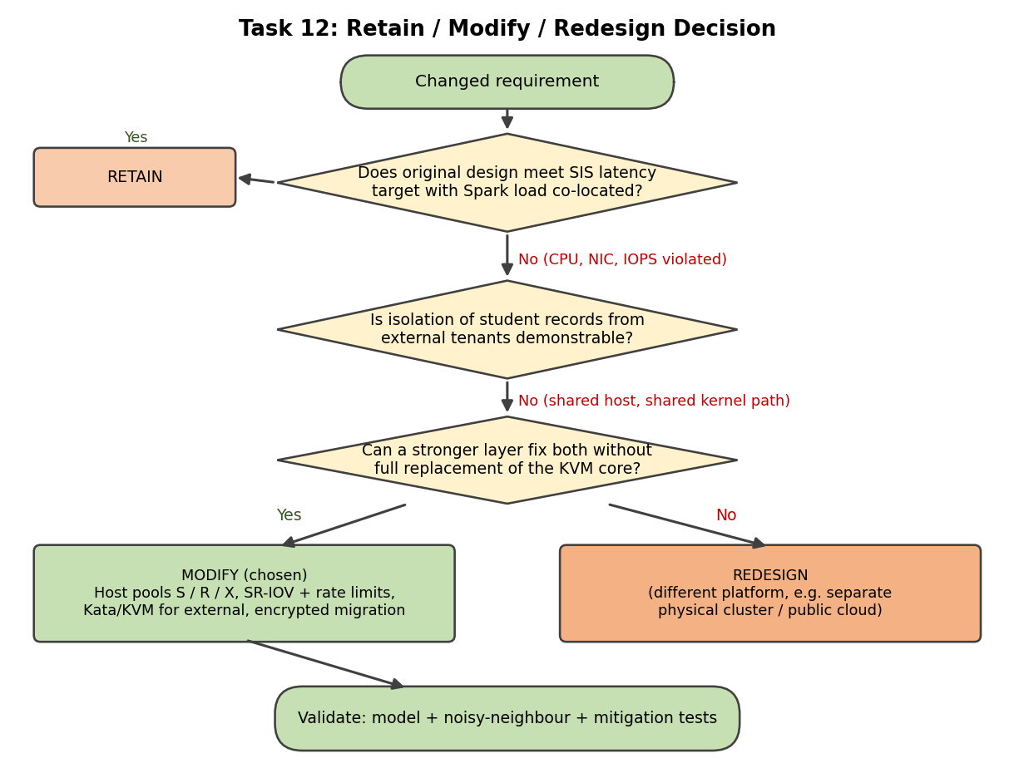
Figure 10: Decision flowchart for retain / modify / redesign
Decision: MODIFY. The KVM core is kept because it already satisfies the SIS requirements (Task 11). What fails is co-location, so separation, a stronger isolation layer for external tenants and I/O isolation are added; a full redesign of the platform is not needed.
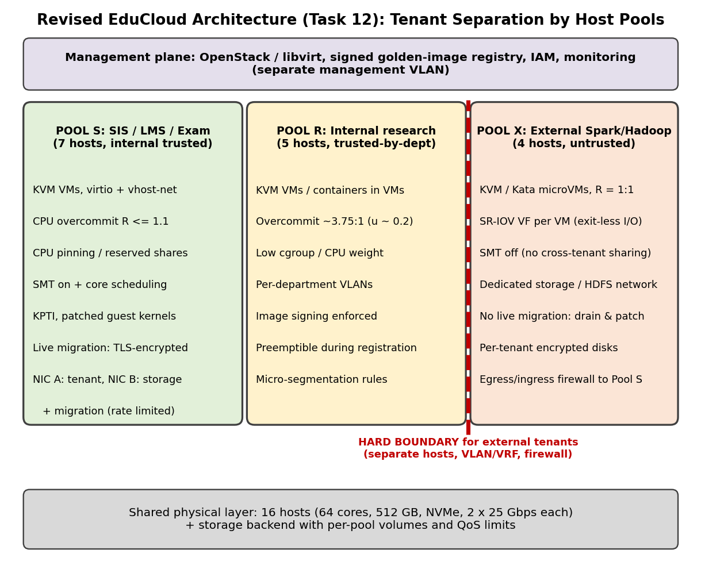
Figure 11: Revised EduCloud architecture with tenant separation by host pools
Pool | Hosts and capacity | Configuration | Effect on density, throughput, attack surface
S: SIS, LMS, exam portal | 7 hosts, 16 VMs each = 112 slots for 100 VMs | KVM + virtio/vhost, R ≈ 1.0, no memory overcommit, core scheduling, KPTI, TLS-encrypted migration over NIC B, signed images | Density down from 25 to 16 per host, but L = 1.06 at peak (was 1.48) and 1.47 Gbps and 14,700 IOPS per VM (was 0.29 Gbps). No external tenant on these hosts
R: internal research | 5 hosts, 60 VMs each = 300 VMs (R = 3.75, u ≈ 0.2, ρ = 0.79); memory 498 GB needs ballooning/KSM (working set 5 GB) | KVM or containers, low CPU weight, per-department VLAN, preemptible during registration | High density kept; cannot disturb SIS because it is on different hosts
X: external Spark/Hadoop | 4 hosts, 8 Spark VMs (8 vCPU, 32 GB) each = 32 VMs at R = 1.0 | KVM/Kata, one SR-IOV VF per VM with rate limit (23.5/8 = 2.9 Gbps each), SMT off, dedicated storage network and encrypted per-tenant volumes, firewall towards Pool S | Overhead ≈ 5.2%, near line-rate shuffle, no host CPU in data path; shares no host, kernel, SMT sibling or NIC with SIS

- Live migration and patching: Pool S is patched by TLS-encrypted live migration (8 GB VM in about 7 s on a 10 Gbps capped migration network). Pool X cannot live-migrate (SR-IOV passthrough), so it is patched by draining one host at a time (YARN graceful decommission, Spark lineage recompute, HDFS replication), costing 25% of Pool X capacity during a window scheduled between job waves.
- Attack surface: before the change the shared elements were host, hypervisor, kernel, SMT siblings, NIC, storage queue and management plane. After it, only the storage backend (separate volumes with QoS) and the management plane (own VLAN, RBAC, MFA, audit log) are shared, and both can be documented for the regulator.
- Evidence of isolation for the regulator: libvirt XML showing pool membership, scripted tests that traffic from Pool X to Pool S is blocked, SMT-off check (lscpu), signed image list and migration TLS configuration.

D. Evidence-Based Defence
Claim | Evidence
Retaining the original design is not acceptable | Task 3 model with the new load: SIS dilation 1.48 against 1.11, 0.29 Gbps against 0.5, 4,800 against 5,000 IOPS, and no demonstrable isolation (Section B)
Redesigning the platform is unnecessary | KVM meets the SIS target (o = 5.3% typical, L = 1.06) and has the strongest isolation score; the problem is co-location, not the technology (Tasks 3, 5, 6, 11)
Separation by host pools solves both problems | Model results: Pool S at R = 1.0 gives L = 1.06 and ≥ 1.47 Gbps per VM; Pool X on SR-IOV removes the I/O exits (o = 5.2% instead of 12.3%)
The costs are acceptable | Task 7: core scheduling costs about 8%, SMT-off 20% (used only in Pool X), KPTI 1.2%, micro-segmentation 0.5%, migration encryption 2%. The 16 hosts are unchanged and Pool S runs at about 33% average utilisation at normal load
Experiments will confirm or correct it | Noisy-neighbour test (Task 8): victim p95 dilation predicted 2.11× on a shared host and about 1.06× when the noisy VM is on another pool. Mitigation test: SMT-off capacity loss predicted at about 20%. If measured values differ, re-size Pool S with the measured o; the separation decision does not depend on it

Option | Extra hosts | SIS target at 3× peak | Isolation of records | Verdict
Retain (shared 16 hosts) | 0 | Not met | Not demonstrable | Rejected
Redesign: separate physical cluster for external tenants | +4 hosts (32 Spark VMs at 8 per host) | Met | Demonstrable | Feasible but costs hardware
Modify: host pools S / R / X | 0 | Met | Demonstrable | Chosen

The decision follows from the analysis: the original design fails on three quantified service targets and on the regulatory requirement, KVM remains the best isolation unit for student records, and host-pool separation with SR-IOV for the external tenants meets all targets with the existing 16 hosts.

